**How to Get Web API Project?**

* Create a folder in your local machine at any destination you want.
* Open the folder and in the destination tab as shown in the below picture write **cmd** and press enter:

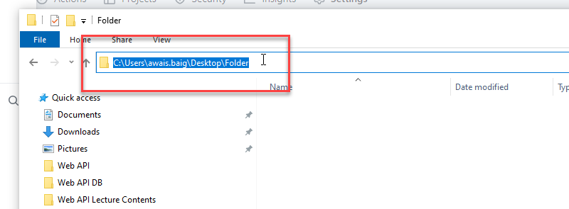

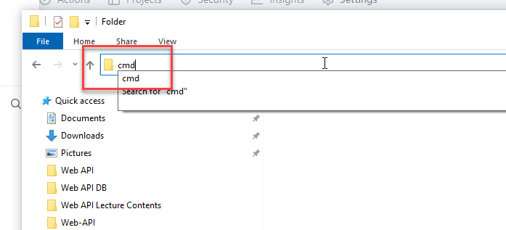

* As you will press enter the command prompt will open up and you have to use the following command:

**git clone** [**https://github.com/AwaisBaig17/Web-API.git**](https://github.com/AwaisBaig17/Web-API.git)

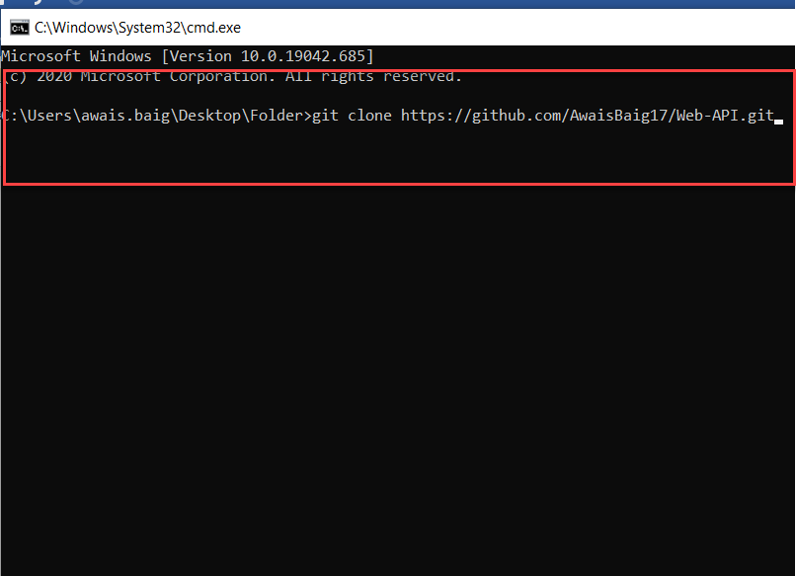

* After this the folder will be cloned and you just have to install the packages.